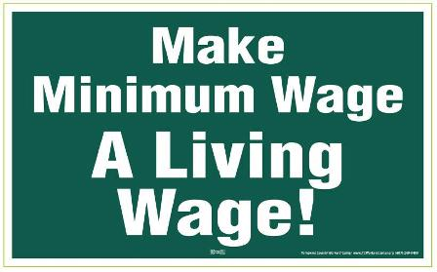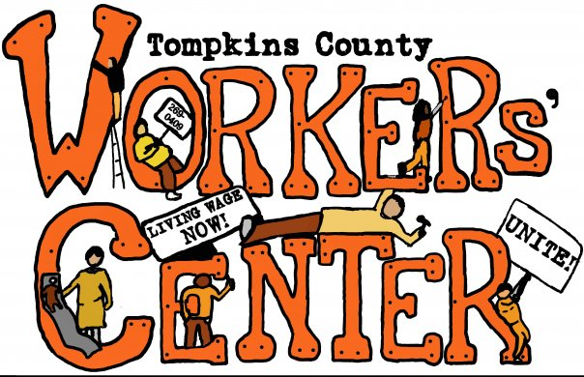
I Support Raising the Minimum Wage to a Living Wage in Tompkins County!

Working families all across the country are demanding a fair minimum wage. A fair minimum wage is a Living Wage and in Tompkins County the Living Wage is $15.11/hour. I support raising the minimum wage in Tompkins County to $15.11/hour so that all workers can feed and care for their families and pay their rent. By signing this petition, I call on the Tompkins County Legislature to pass a local law on this NOW.

Printed Name | Address, along with City/Town | Email | Phone

1)

2)

3)

4)

5)

6)

7)

8)

9)

10)

11)

12)

Tompkins County Workers’ Center
115 E. Martin Luther King, Jr. Street (above Autumn Leaves Used Books), Ithaca, New York 14850
(607) 269-0409 TCWRH@tcworkerscenter.org www.TCWorkersCenter.org

